Title: IoT based energy wastage detection and notification system
Description:
This system uses IoT sensors to continuously monitor electrical energy consumption of devices. It detects energy wastage caused by unused or inefficient appliances. When wastage is identified, the system sends instant notifications to users, helping them take quick action to reduce power consumption and improve energy efficiency.

Block diagram:
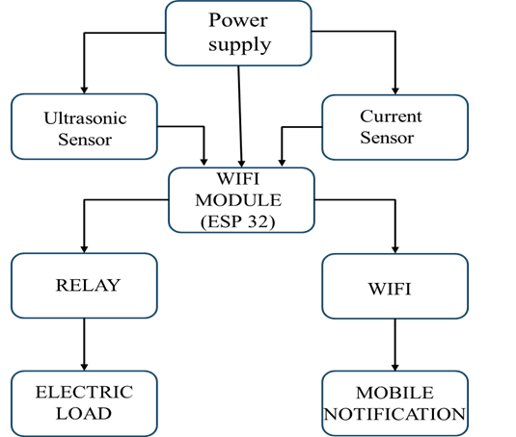

Figure 1.1 Block Diagram

HARDWARE IMAGE:

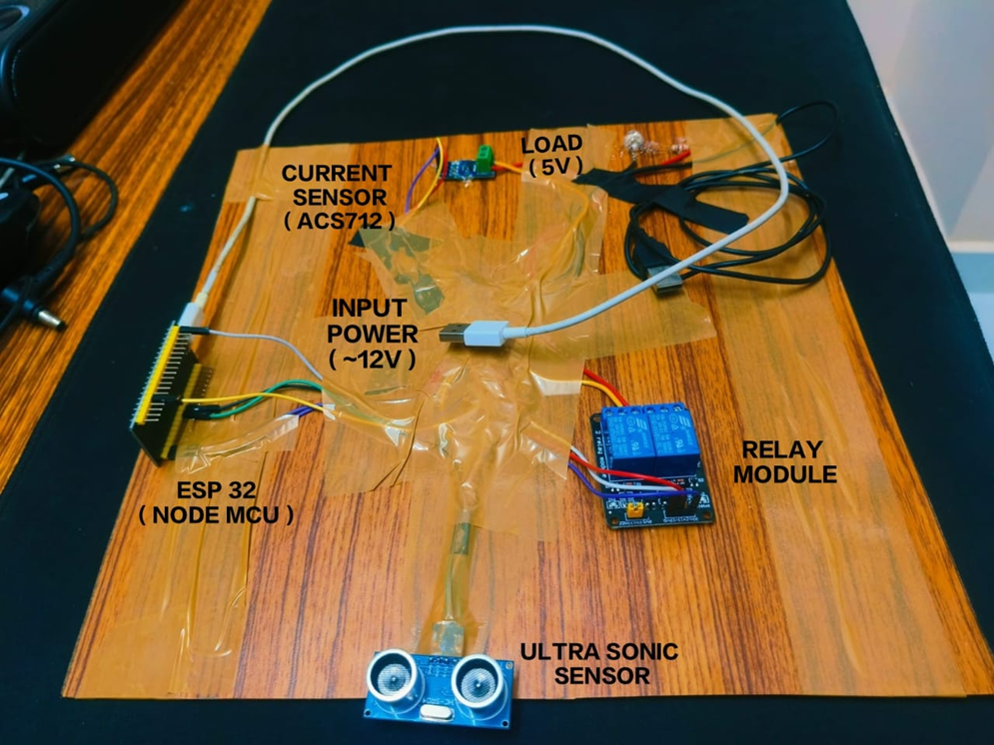

CIRCUIT DIAGRAM:
